Grade 5
Loco Dispatcher: Explorations of Time, Distance, and Rate of Speed

Description: | Students will:  Model a mathematical formula.  Make an interactive mathematics book.  Choose the topic.  Plan the pages.  Create text, illustrations, and programming.  Use digital images from the internet.  Cite the sources for digital images.
Project View | 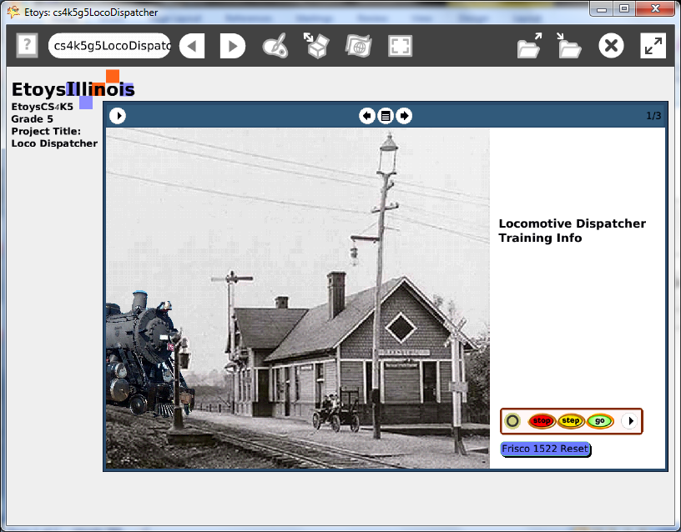
Subject: | Mathematics, Language Arts
Etoys Quick Guides | Click the question mark in Etoys to open the set of interactive tutorials for basic tools and techniques.
Vocabulary: | Scale factor, x and y locations, < >, conditional statements, variables, heading, fractions, decimals, tenths, hundredths, distance, time, rate of speed, formulas, increase by, decrease by, scale factor, digital images, x and y locations
Lesson 1:  Books: Top Border Icons  Books: Expanded Controls  Books: Working with Layers  Supplies: Text  Supplies: Digital Images  Navigator Bar: Keep Find Project | This book project is designed to give 5th grade students a purposeful project to communicate interesting mathematical information. Making these interactive models will help them visualize concepts and deepen their knowledge.  Students gain experience by combining ideas from mathematics, language arts, and programming.  All the books do not need to be the same topic. They should be as varied as the students’ interests. When they are finished they provide a resource for other students.  Use a real book as an example to help students understand the parts of the book, a real book and a virtual one. Proficiency in working with layers takes time to develop.  Drag a book from Supplies.  Fifth grade students should type the text for their book.  This example project uses these Quick Guide tools and techniques:  Page 1 digital images from the internet for the train and the station  Scale factor, x and y locations, < >, increase by, conditional  Statement, heading  Page 2 variables, speed, distance, constructed tiles using variables,  conditional statements, scripting controls, x and y locations  Page 3 variables, speed, distance, time, constructed tiles, x and y  locations, a flap with information about using the formula tools  Keep the project. Name it: NameCounts e.g. KateMathBook  Give students time to read the mathematics books by other students in the class.
Standards: | Common Core Standards  Mathematics: 5.OA; 5.NBT.3.7; 5.NF.2.3.4.5.6.7; 5.MD.1.2; 5.G.1.2  Language Arts: 5.W.2.a.b., 2. 6.; 4.L.1.2  Bloom’s Taxonomy/Cognitive Domain:  Knowledge: knows  Comprehension: gives examples, rewords,  Application: demonstrates, produces, uses, changes  Analysis: analyzes, compares, experiments, plans  Synthesis: categorizes, explains, creates, modifies, plans  Evaluation: compares, reviews, investigates  NETS:  1. a, b  2. b  4. a, b  5. a, b, c, d
Resources: | Etoys Help Quick Guides: always available in Etoys. Open Etoys and click the question mark to open a set of interactive tutorials of basic tools and techniques.  www.etoysillinois.org projects, lesson plans, software download  www.mste.Illinois.org more math, science, and technology resources  www.corestandards.org Common Core Standards  www.squeakland.org software and Etoys projects  www.nctm.org Standards and Focal Points for each grade level
kh February 2011

